Design Document

**EXT100MI**

# Requirement

As we don’t have a standard API to modify the Planning date (PLDT), Confirmed delivery date, and Departure date of customer orders, we build the below API transactions.

As the customer is dependent on the 3PL logistic to ship the goods, the customer would like to wait for the supplier to send the shipping and other necessary dates. Once we receive those details, we will modify the customer order.

And we have a requirement to update the Quantation number on the customer order header. So we have built the below API transactions.

# Document Control

Title: Ruiz cloud

Developed by: Girish Kumar Hosamani

Date: 12/02/2023

Version: 1.0

# Design Details

## EXT100MI Transaction Overview:

Transaction Overview

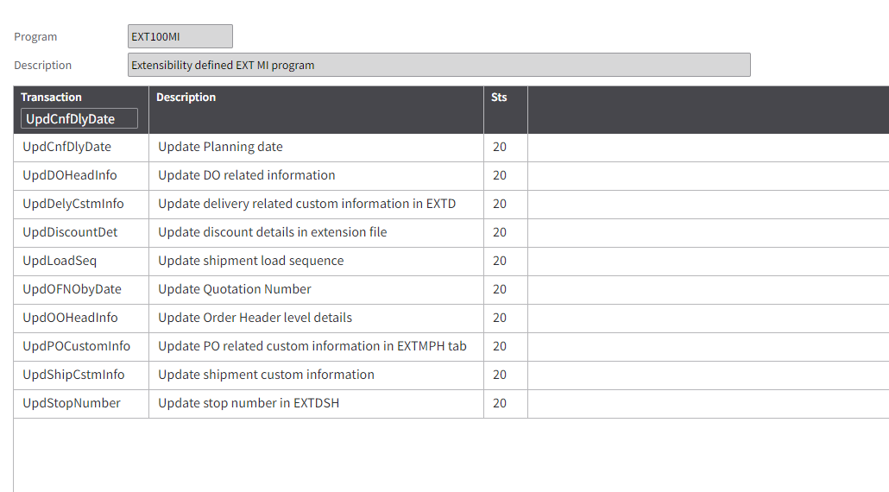

EXT100MI.UpdCnfDlyDate - To update Order Line with the Planning date, Departure date, and Confirmed delivery dates.

EXT370MI.UpdOFNObyDate - To update the Quantation number at the Order header level.

## Tables Overview

M3 Tables: "OOHEAD" - CO header

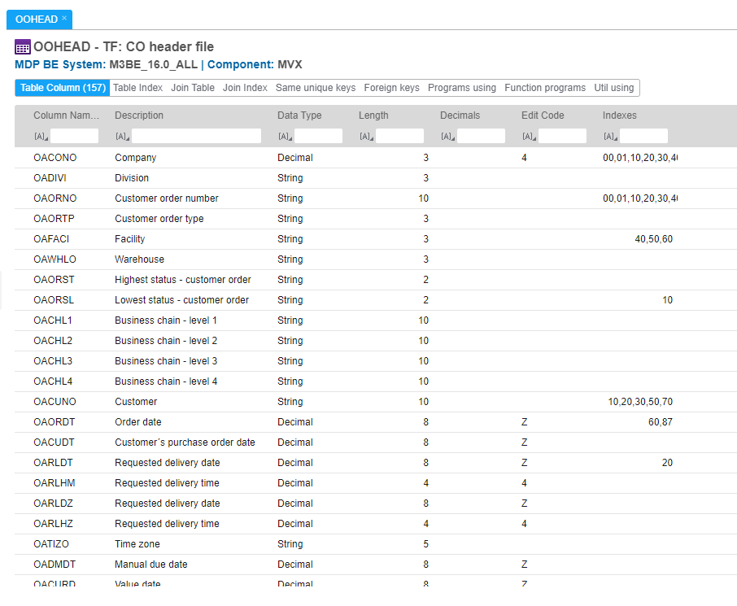

M3 Tables: "OOLINE" - CO line

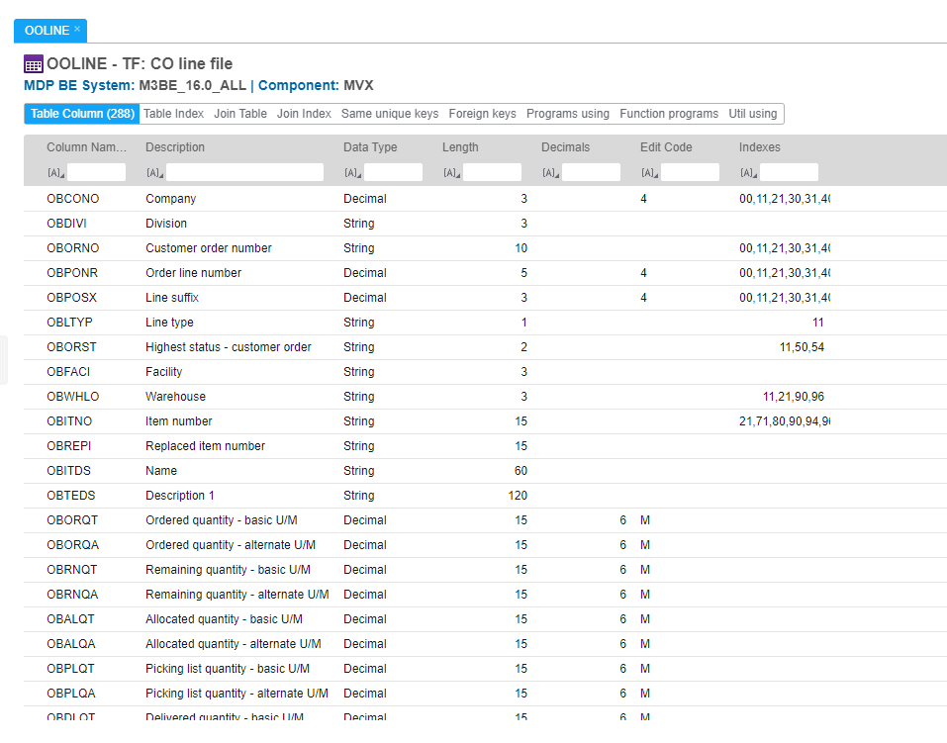

M3 Tables: "MITPLO" - Material plan

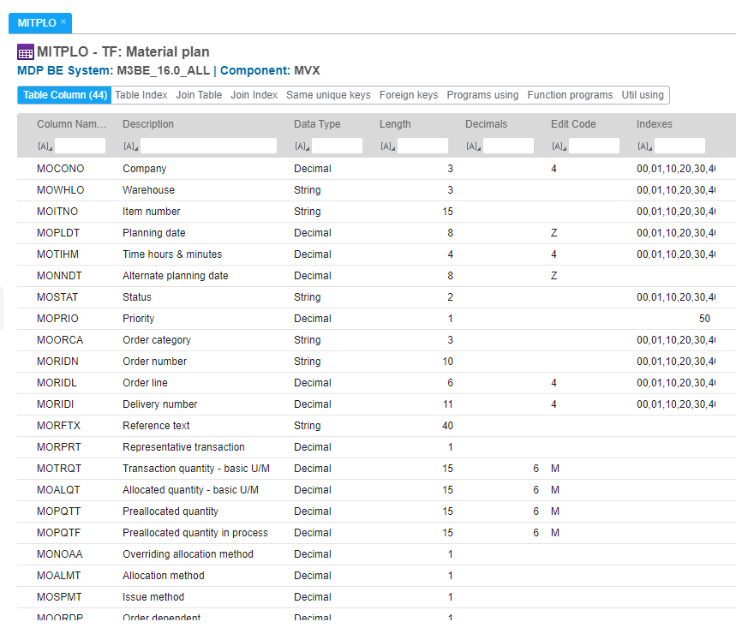

M3 Tables: "MMM920" - Allocation 1/(MA)

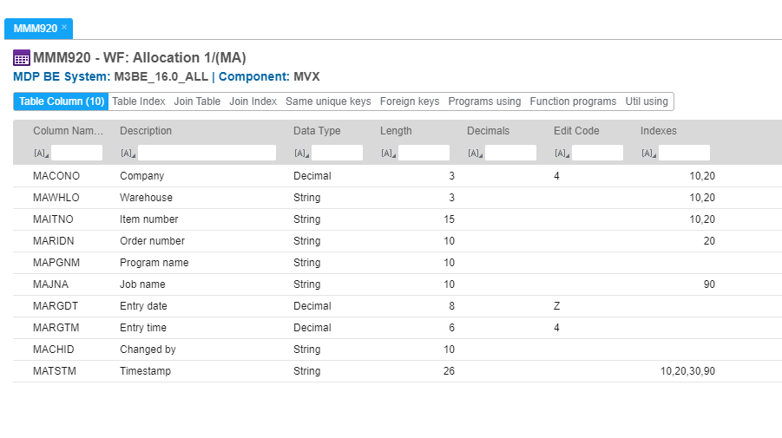

UpdCnfDlyDate

**Purpose** – To update Order Line with the Planning date, Departure date, and Confirmed delivery dates.

**Input Fields**

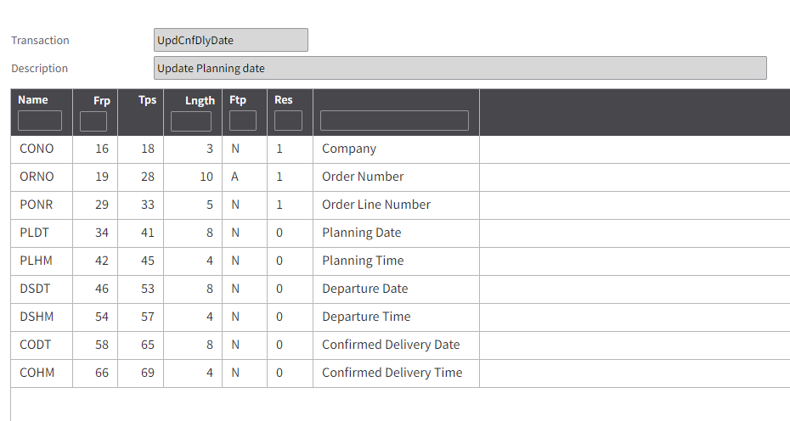

**Output Fields**

* None

**Tables Read**

“OOLINE” CO line

“MITPLO” Material plan

“MMM920” Allocation 1/(MA

**Logic**

Check all the input fields are not blank and validate the existence of the input values Order line. And also validating the input date format.

If all input values are valid then it will update the planning date (PLDT), Confirmed delivery date, and Departure date of the customer order line.

If an order does not exist then throw an expectation for missing records.

UpdOFNObyDate

**Purpose** – To update the Quantation number at the Order header level (OOHEAD).

**Input Fields**

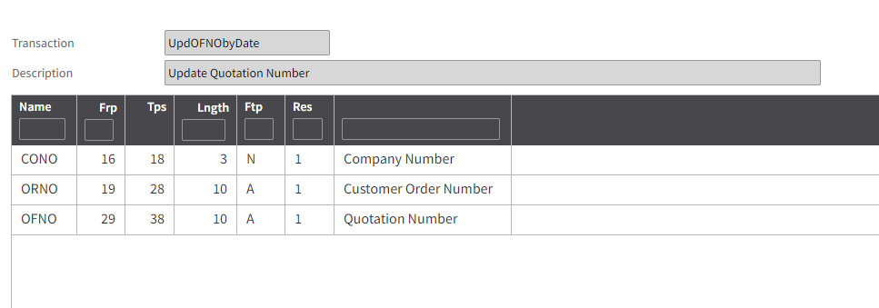

**Output Fields**

* None

**Tables Read**

“OOHEAD” CO header

**Logic**

Check the mandatory input fields are not blank and checking the input CO number is valid or not. If the record exists in the table then update the Quantation number at the Order header level, if it does not exist then throw an expectation for missing records.